**TO SUPPLY LEFTOVER FOOD**

**College Name: UNITED COLLEGE OF ARTS AND SCIENCE**

**College Code: 641020**

**TEAM ID: NM2025TMID27727**

**TEAM MEMBERS:**

**Team Leader Name: SARANYA S**

**Email:** [saranyasuresh1602@gmail.com](mailto:saranyasuresh1602@gmail.com)

**Team Member1:  SHEIK FAIZ P M**

**Email:**  sheikfaiz424@gmail.com

**Team Member2: SHREE** **SARAVANAKUMAR J**

**Email:**

**Team Member3:** **SHAJAKHAN N**

**Email:**

**Team Member4: SUTHIKSHA M**

**Email: suthikshasuthiksha34@gmail.com**

**1.INTRODUCTION**

**1 Project Overview**

This project is designed to manage the collection and distribution of leftover food from restaurants, hotels, and events to underprivileged communities. Using Salesforce CRM, the system streamlines donor registration, food collection requests, volunteer coordination, and delivery tracking. The app ensures transparency, reduces food wastage, and creates social impact by connecting food donors with beneficiaries efficiently.

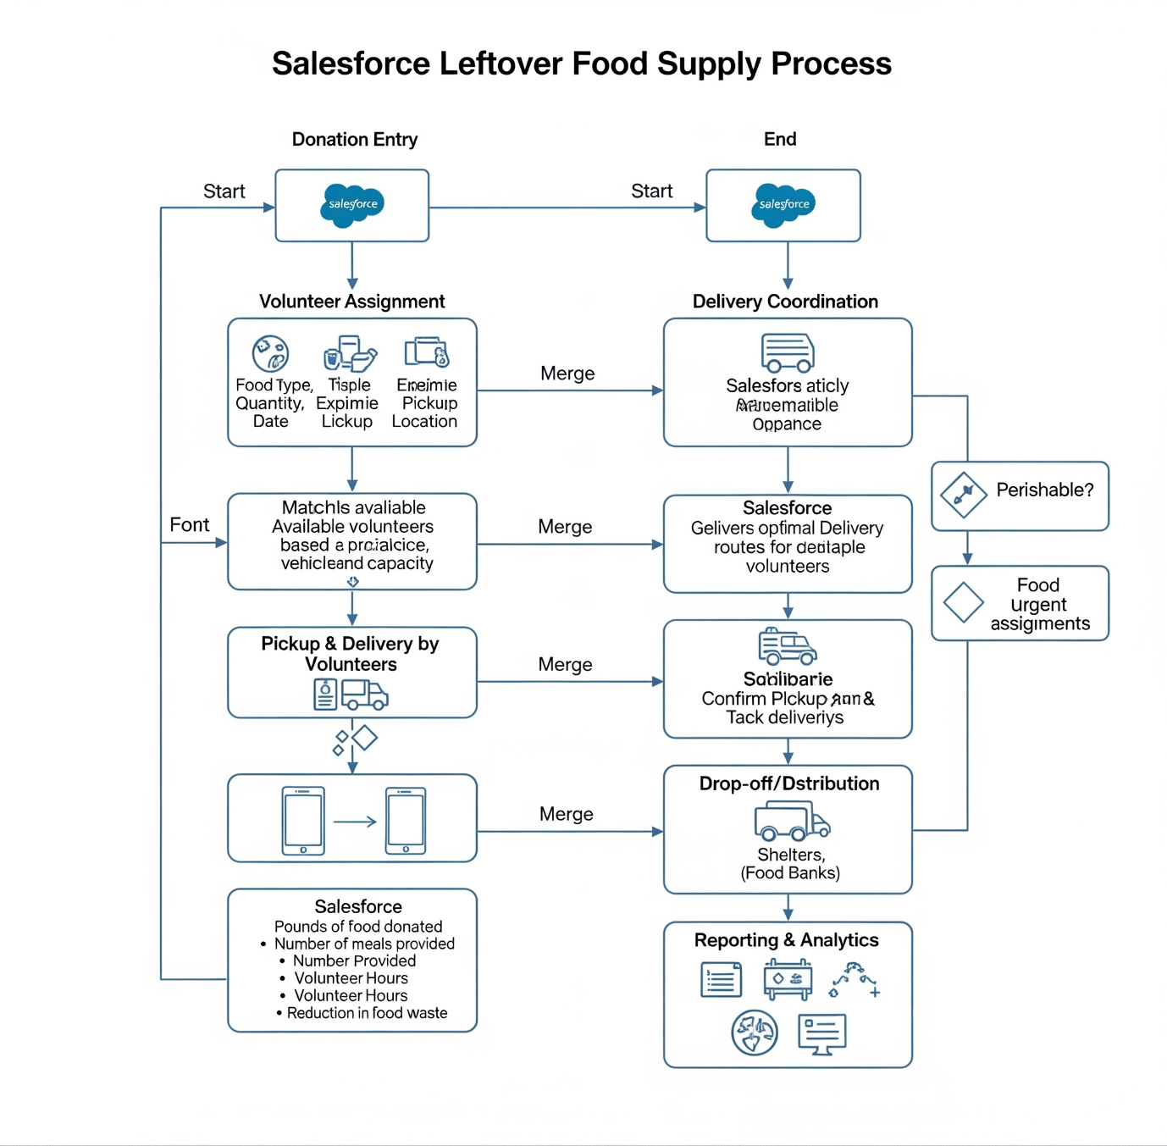

**Objectives**

Enable restaurants and donors to log leftover food details quickly.

Automate the allocation of volunteers for food pickup and delivery.

Provide real-time tracking of food donations and beneficiaries served.

Maintain records of donors, volunteers, and food distribution events.

Generate reports and dashboards for transparency and impact measurement.

**Key Features & Salesforce Components**

Custom Objects:

Donor (Restaurant/Individual providing food)

Food Donation (Details of leftover food, quantity, expiry time)

Volunteer (Person assigned for pickup/delivery)

Beneficiary Location (Orphanages, shelters, NGOs)

Delivery Record (Tracks pickup and drop-off completion)

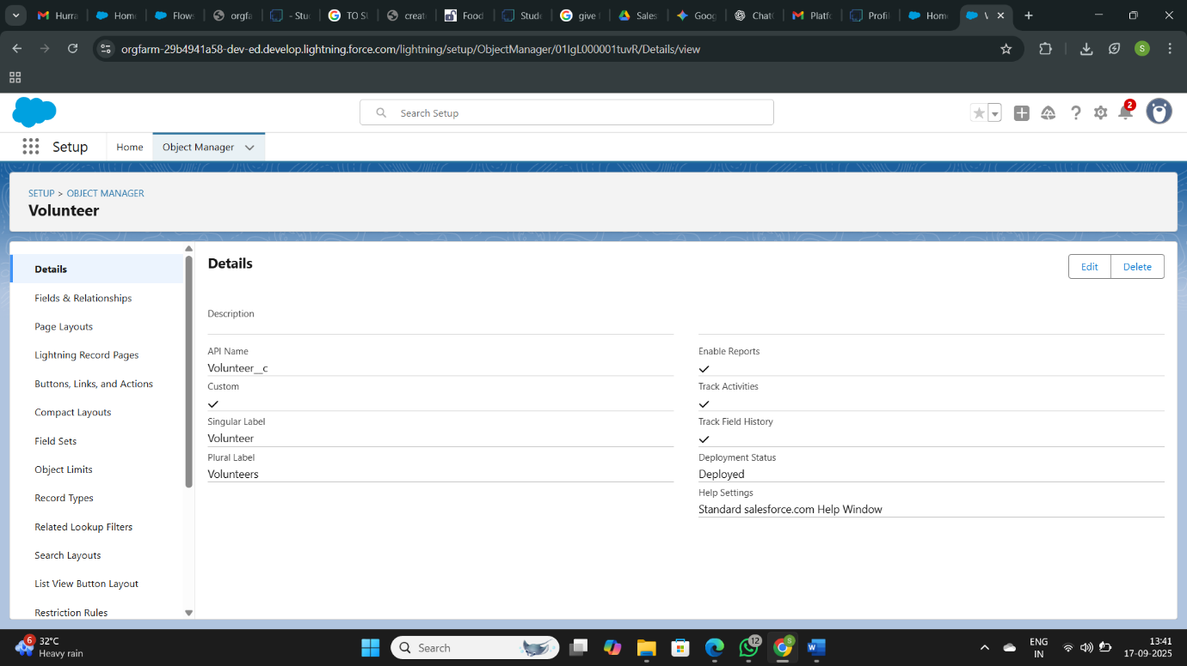

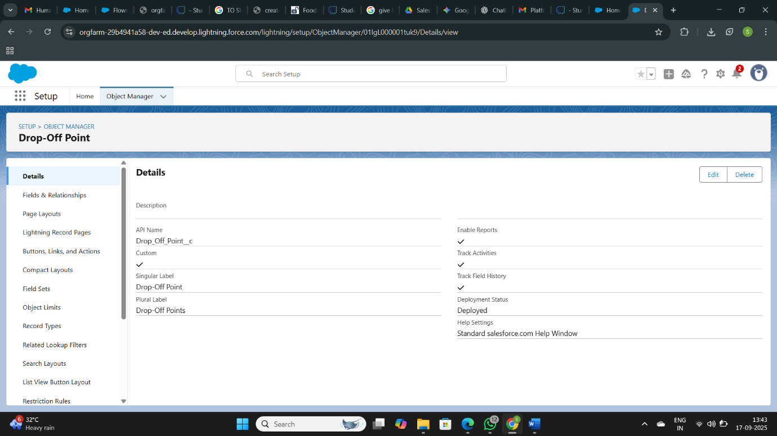

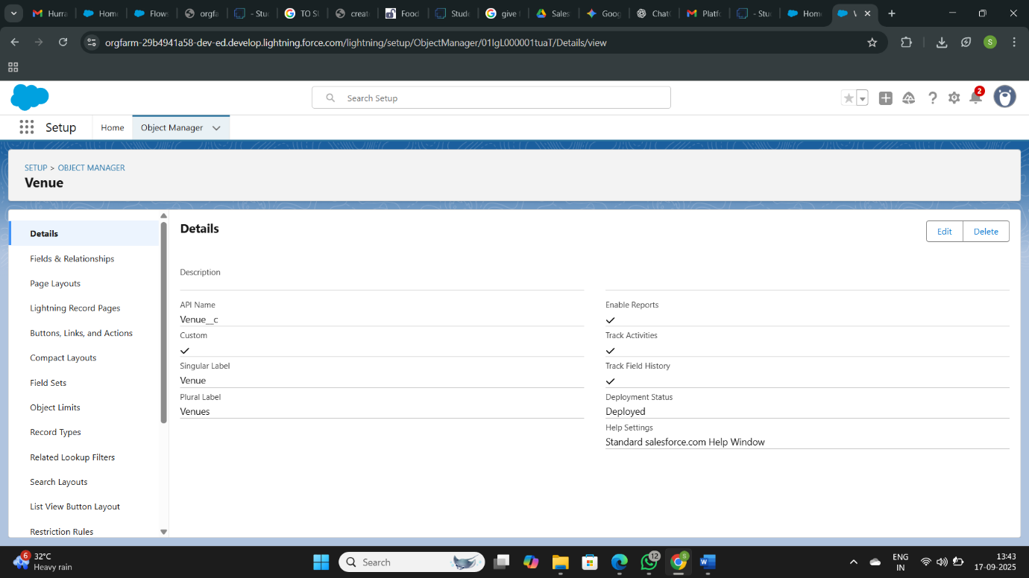

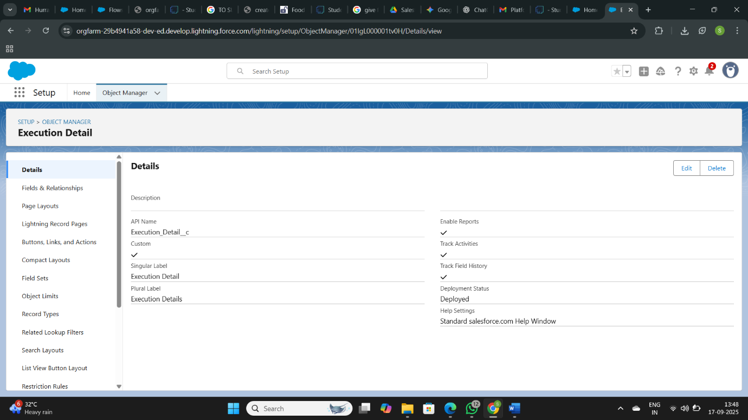

The above all the screenshots are details of created objects. The objects are venue, drop of point, task, volunteer . then move to the next part fields and relationships on the objects

* **Configured fields and relationships**

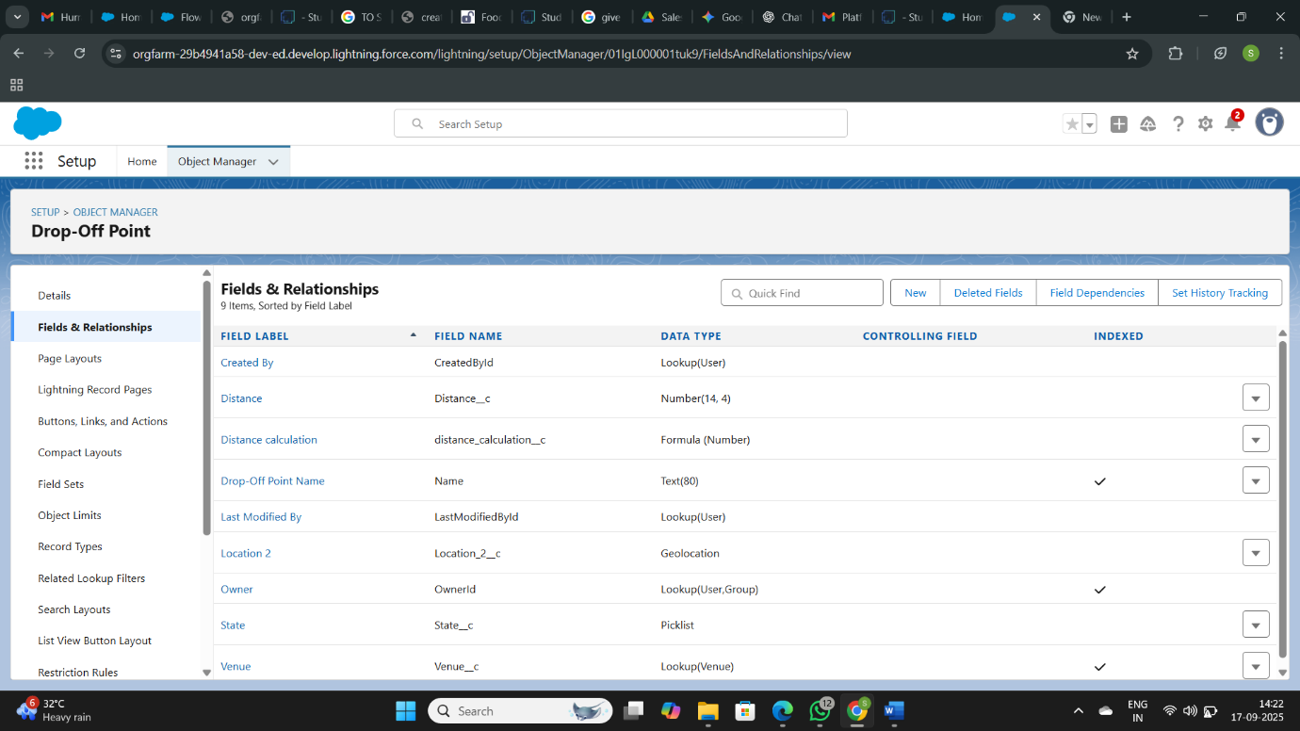

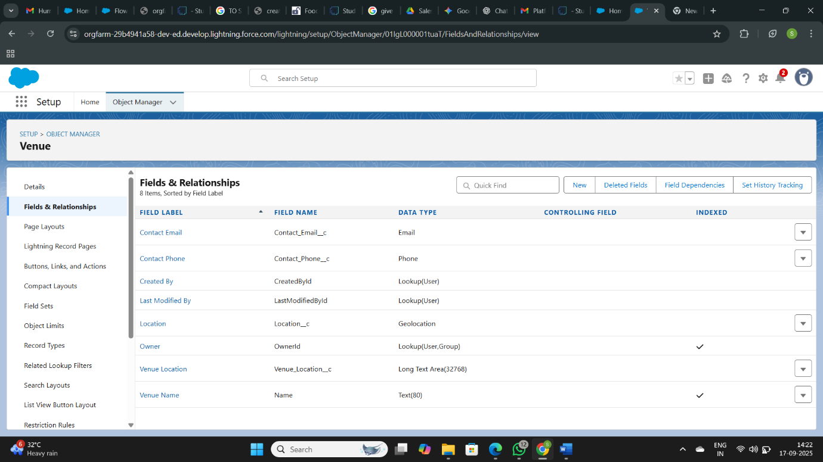

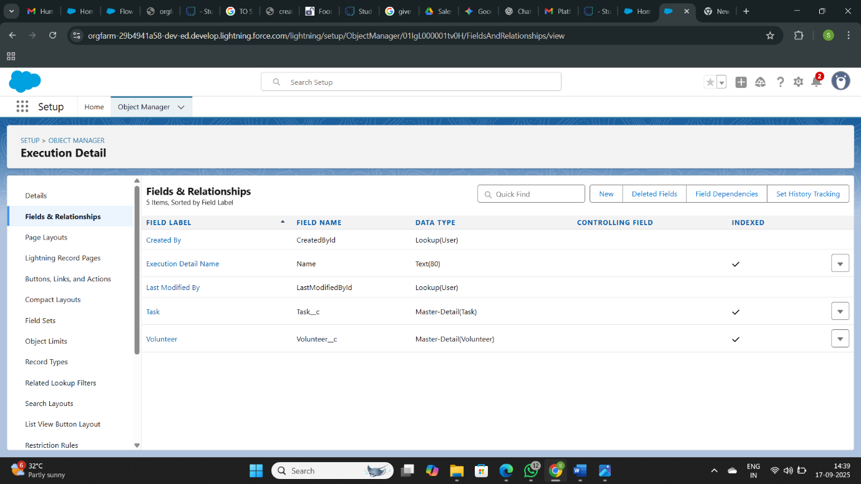

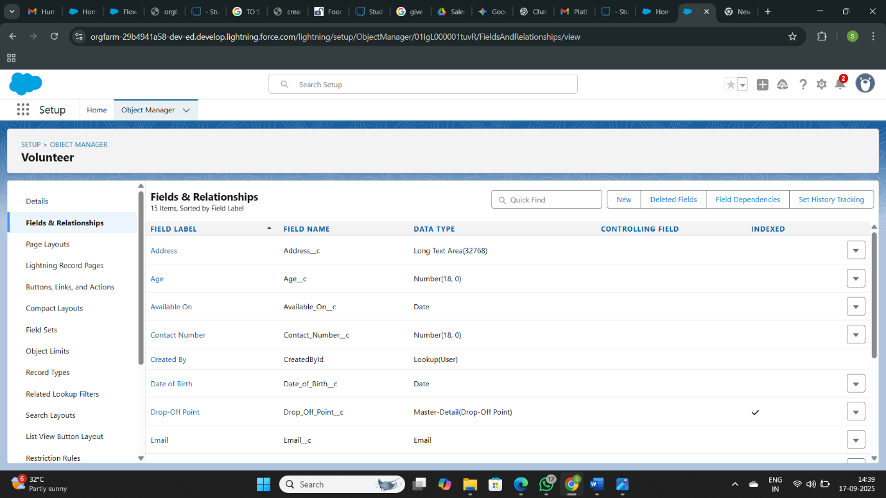

**● Developed Lightning App with relevant tabs**

Creating tabs:

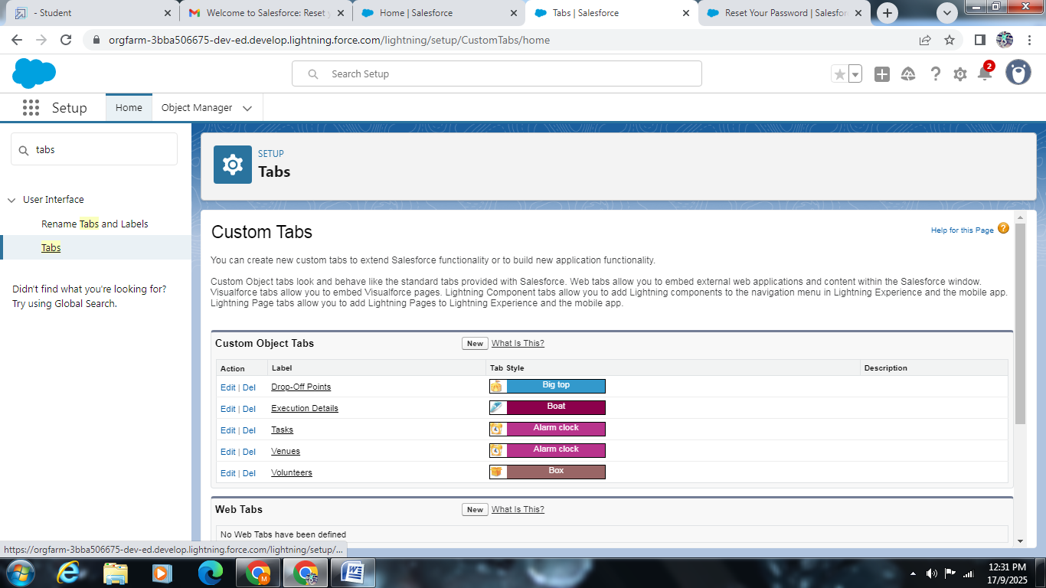

Creating lightning app:

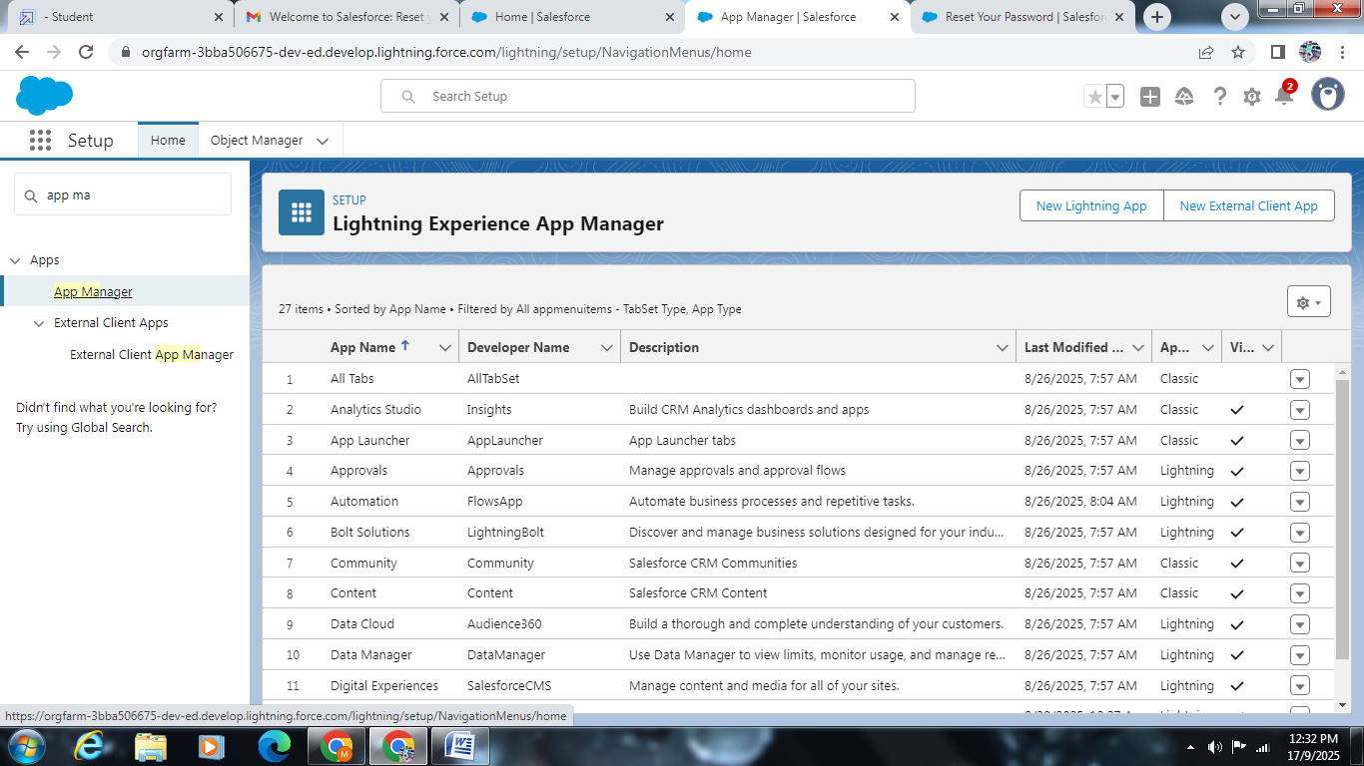

Fields: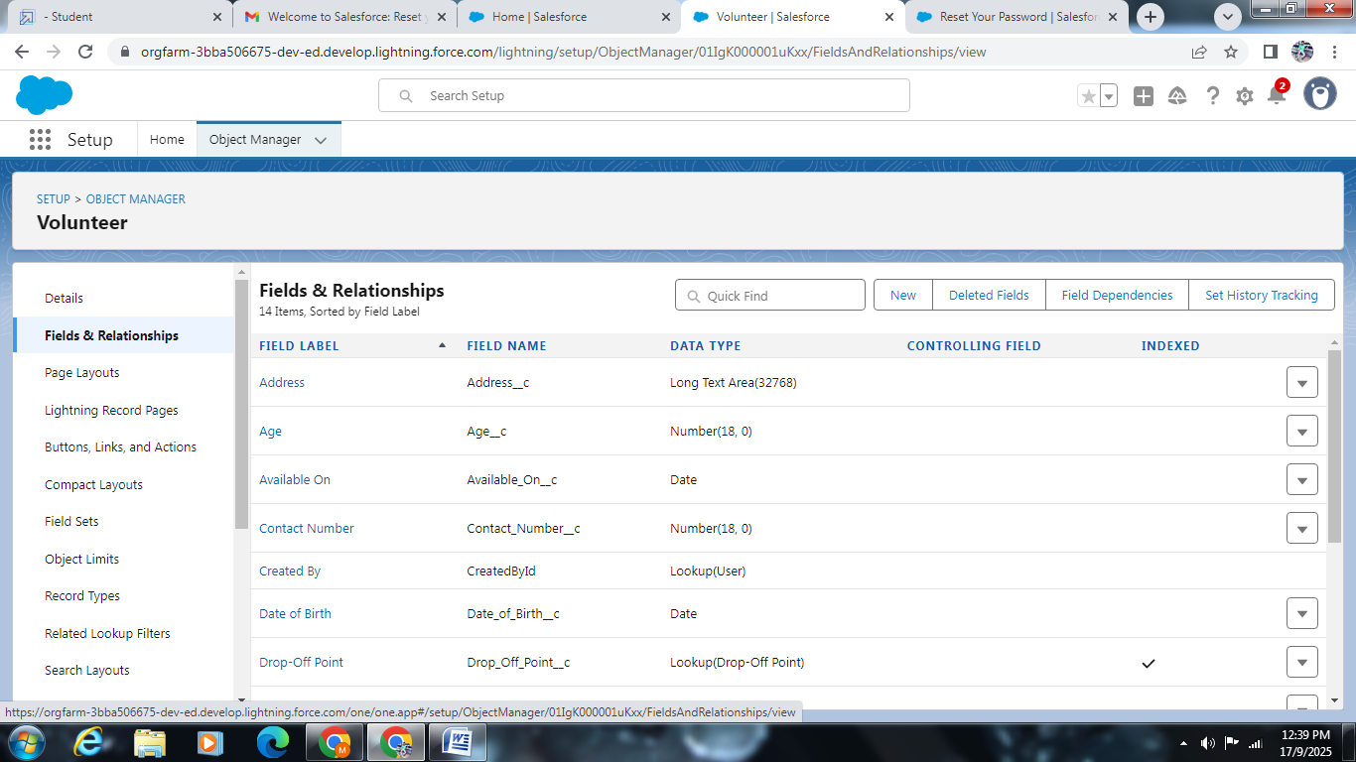

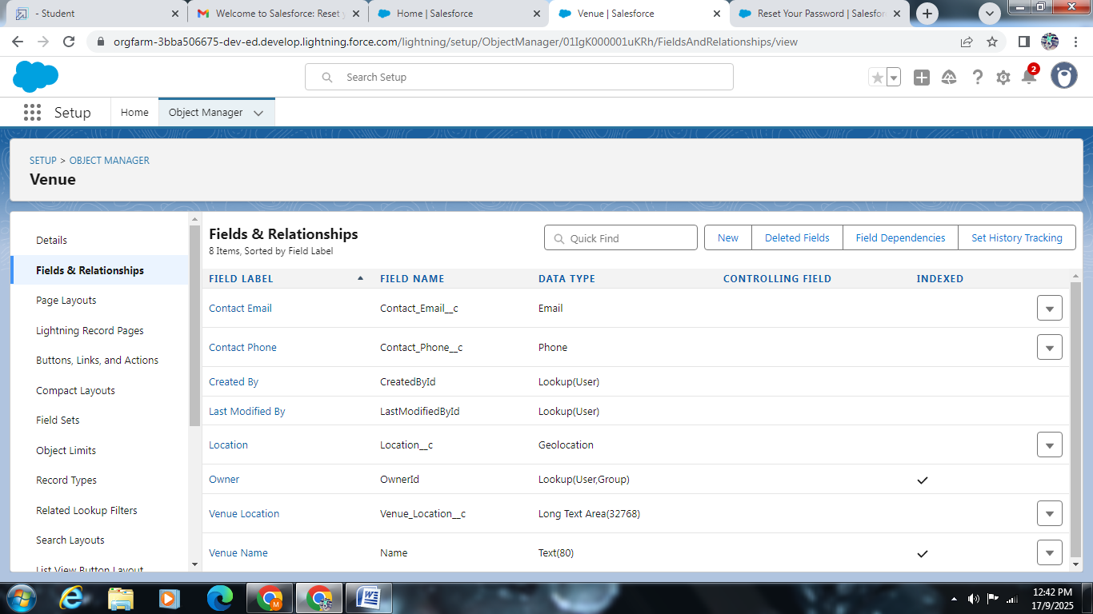

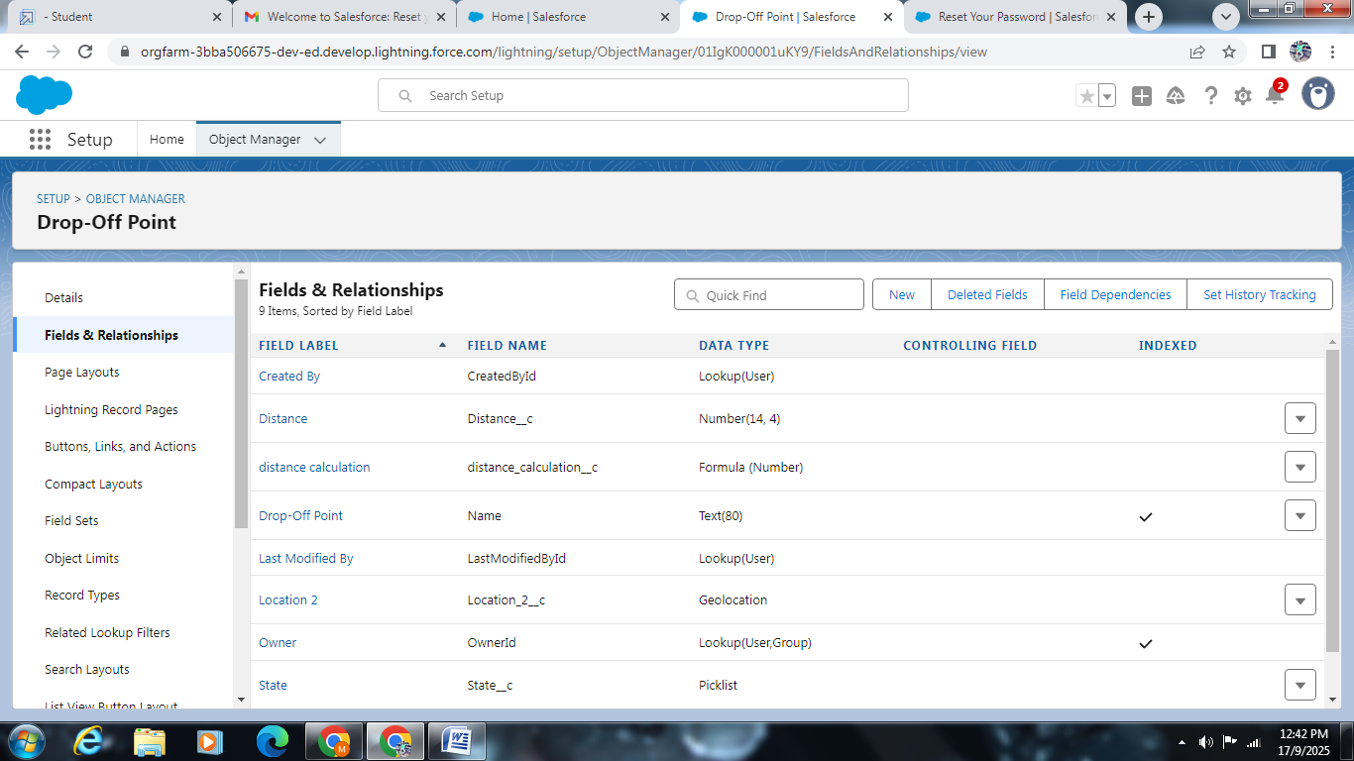

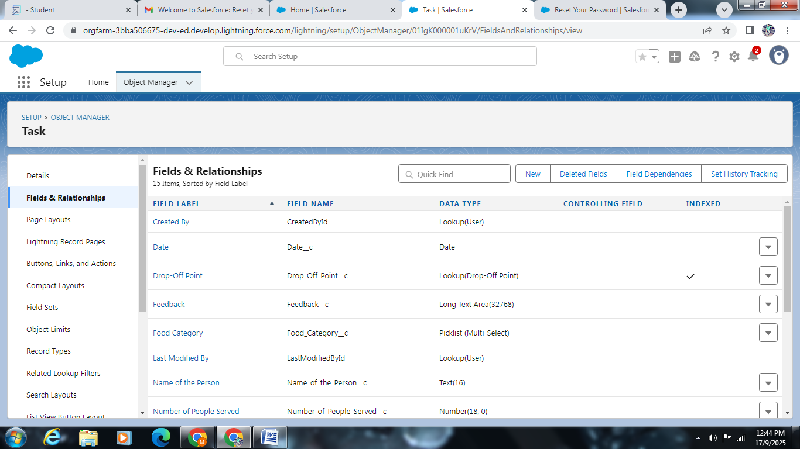

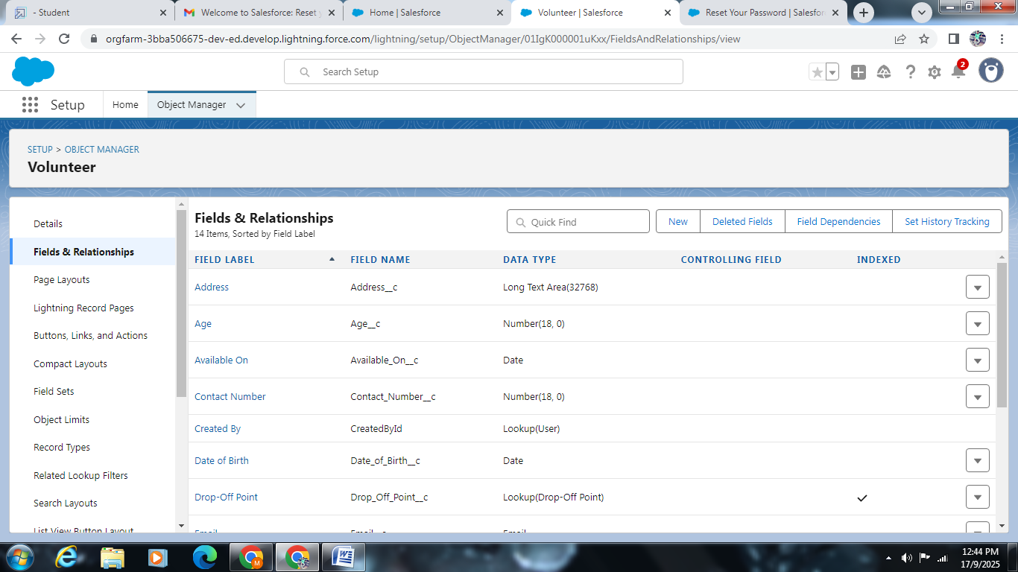

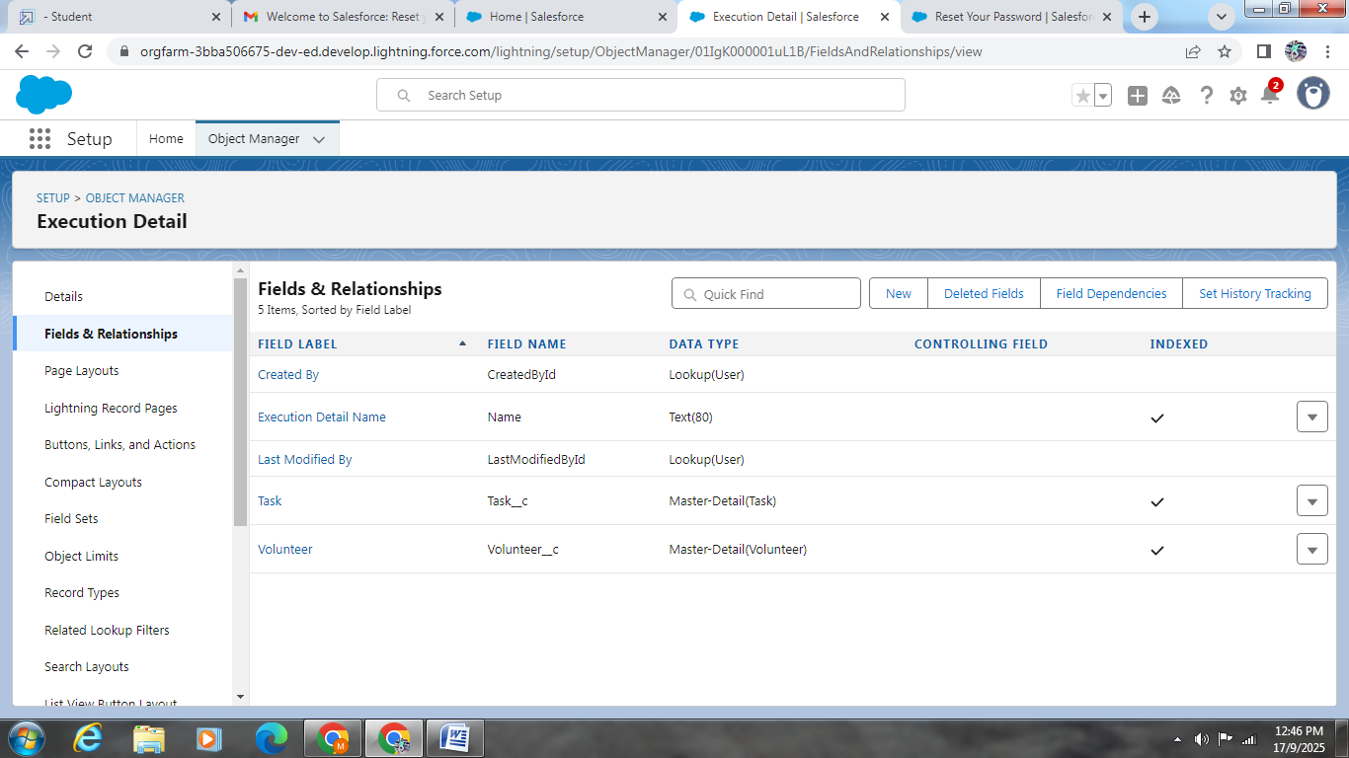

Create Flow To Create A Record In Venue Object: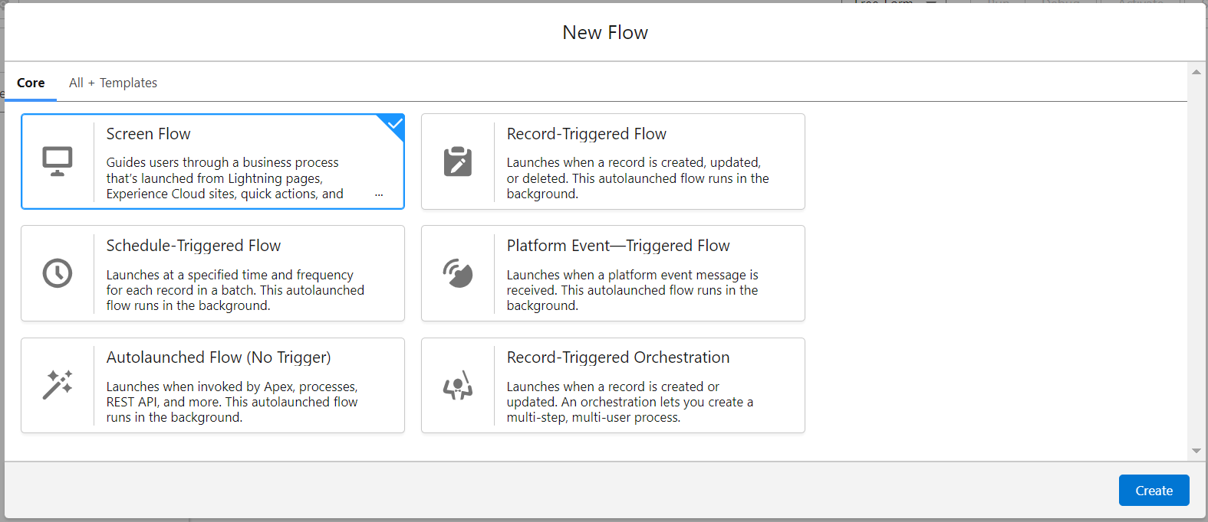

Profiles:

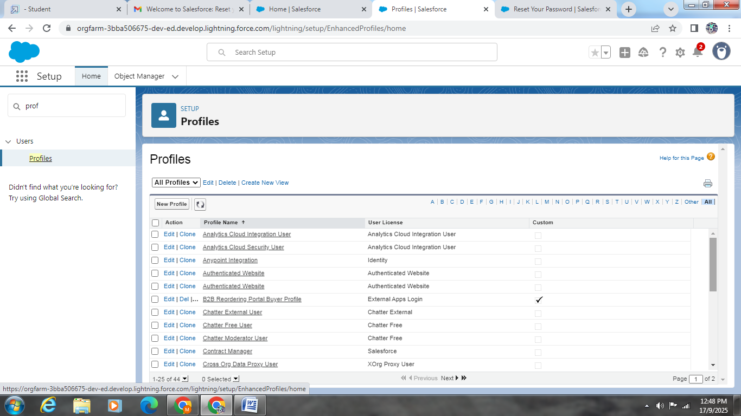

### Creation Of Users:

### Public Groups:

Daily food collected vs. distributed.

Top donors and volunteers by contribution.

Impact metrics (Meals served, food wastage reduced).

### Report Types:

### Creation Of Report On Venue With DropOff With Volunteer: https://lh7-us.googleusercontent.com/aLpsRo5squAngR2vpoDv2CBOONYebVQHB1qrciHOTwn6lNqOmuJVql_BYOCcnkH8ci2Txf1WZYTBMAwVd4yDvIbfYF0T86UDRv_FoDDbcI4QyWiRWGJCGYP2F4wflHTo8_G5IRHJcX0_KXI3sMKohq4

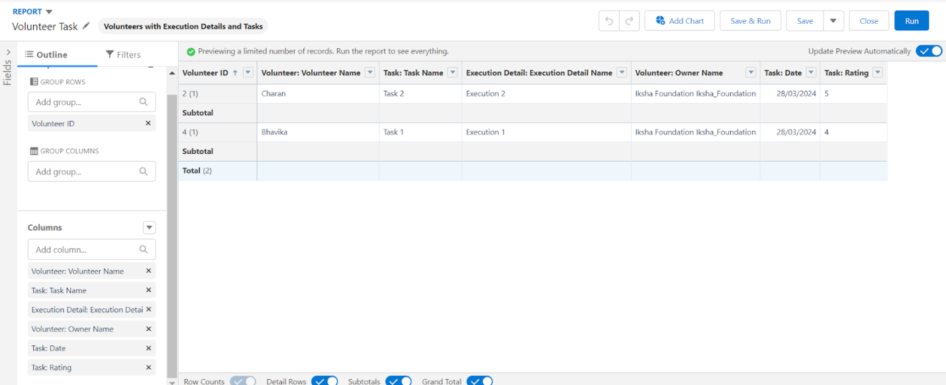



### Dashboards: https://lh7-us.googleusercontent.com/JfY26Oa4CjTrw6ikLSUREE761_ioGaL4c-RHAMgzMvC8crN5YK4p0QS4DE4_TPHhRwVklJitGgK6kyYsKS7y2E8iGvMDi7qupL1Wr-PIWK7mI03kGOYwJiJrXqnEkTKtZfmzBG62GPsLkkUx8f8S_-Y

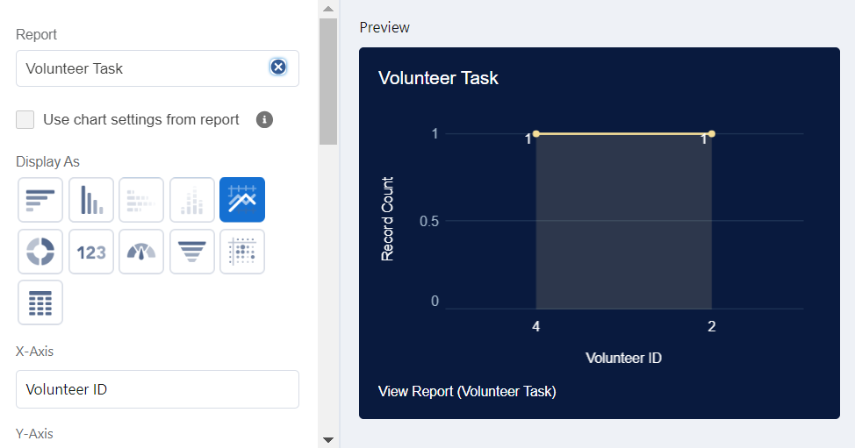

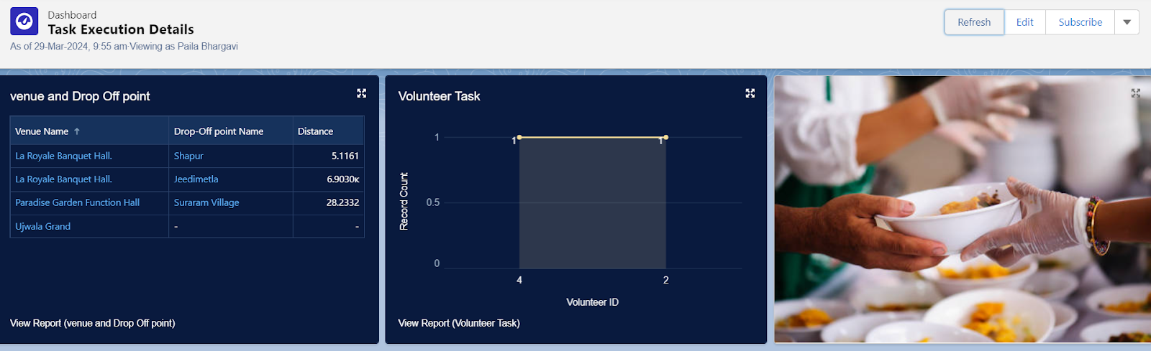

### Creation Of Sharing Rules:

### Creation Of Home Page: https://lh7-us.googleusercontent.com/Phw67W0RHrzPNPRfc5Zm44zw-QSYEb0Wr0Vv7VZZUWKoNX-QSQN99po6eli-QMxh3jKWfwg0_7kcL9SOX6N6ifONooe2KVLPYVEIYGNlUhSF5LmEAD7QEEwrFTuL7xhvVr3Er8WxEAxHJA9ggn57edg

### Conclusion

By leveraging the Salesforce platform, the project successfully established a streamlined and transparent system for managing surplus food donations. Through efficient coordination with volunteers and timely delivery to beneficiaries, the project effectively addressed food insecurity while maximizing the utilization of available resources.

**Appendix**

Source code:provided in apex classes and tigger

dropoffTrigger

trigger DropOffTrigger on Drop_Off_point__c (before insert) {

    for(Drop_Off_point__c Drop : Trigger.new){

        Drop.Distance__c = Drop.distance_calculation__c;

    }

}